Super

Torch Light

*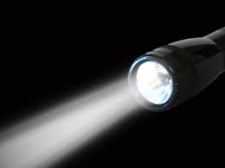*

User Guide

*Light*

*Tomorrow*

*With*

*Today!*

Art no.:1909